MAKING THE DATABASE SCHEMA

- Create the tables : You can create the table in any order
  - Data (main table)
  - Parameter_Description
  - Phenotype_Description
  - Gene
  - Gene_Disease _Relation
  - Human_Disease
  - Parameter_Group_Disease

- Add the foreign keys at the end, after all data has been imported. This makes it much easier to drop or modify tables later if needed.

- Schema adjustments we had to make:
  - In the Data table, we changed the p-value column from VARCHAR to DOUBLE to ensure the values are stored and processed as numeric data.
  - The order in which you create your table columns matters when loading data later. The data is imported according to the column order in the CSV file, so if your table columns don’t match that order, the data won’t import correctly.
  - For the Phenotype Description table, you need to use numeric values for true/false fields. Although ‘Is Mandatory’ is a BOOLEAN column, SQL requires TRUE to be represented as 1 and FALSE as 0. If you don’t convert these values, the data will not import correctly.
  - During the data import, for some tables we received an error indicating that the text in one of the columns exceeded the defined VARCHAR length. To resolve this, we increased the VARCHAR limit for that column and then re-imported the data.
  - When creating a foreign key, we occasionally encountered errors indicating that some values did not match the referenced table. To identify the mismatched entries, we used a query such as:
SELECT DISTINCT IMPC_parameter_origin_id
FROM Parameter_Description
WHERE IMPC_parameter_origin_id IS NOT NULL
AND IMPC_parameter_origin_id NOT IN (
SELECT IMPC_parameter_origin_id
FROM phenotype_procedure);
- This allowed us to locate the problematic values and correct them accordingly.
  - You would need to make sure if
  - In SQL, a dot (.) is interpreted as a separator between table, schema, and column names (e.g., schema.table.column). So, if you name a column DO.disease.id, SQL will not read it normally—it will think DO is a table or schema, disease is a table, and id is the column.

- However, you can you still use dots in the CSV column heading if you quote the column name using your SQL dialect’s identifier quoting e.g.

- SELECT `DO.disease.id` FROM mytable; Best practices is to avoid using dots in column names. It makes queries confusing and requires special quoting everywhere. Instead use underscores it is Much cleaner and SQL-friendly like: DO_disease_id & DO_disease_name

- Important: Ensure that you import your data into SQL in the correct order. If certain tables rely on data from others, importing them out of sequence can prevent some tables from loading successfully.

- SET pvalue = NULLIF(@pval, ''); #Should we add this rule. i have not run the code yet.

- For the Human Disease table we removed ‘Auto-increment’ from DO_disease_id

- Order to LOAD DATA:

Based on the relationships in your ERD, here is the correct and safest order to import your data so all foreign-key constraints succeed.

1. Gene
Why?
Other tables (Data, Gene_Disease_Relation) require gene_accession_id to already exist.

2. Human_Disease
Why?
Gene_Disease_Relation references DO_disease_id from this table.

3. Phenotype_Procedure
Why?
Parameter_Description uses IMPC_parameter_origin_id as a foreign key pointing into this table.

4. Parameter_Description
Why?
It depends on Phenotype_Procedure, but no other table needs to be created before it.

5. Parameter_Group_relation
Why?
This table references parameter_id from Parameter_Description.

6. Gene_Disease_Relation
Why?
Both required parents (Gene, Human_Disease) now exist.

7. Data
Why?
This table references:
gene_accession_id → Gene
parameter_id → Parameter_Description
So it must be imported last.

Final Import Order:
- Gene
- Human_Disease
- Phenotype_Procedure
- Parameter_Description
- Parameter_Group_relation
- Gene_Disease_Relation
- Data

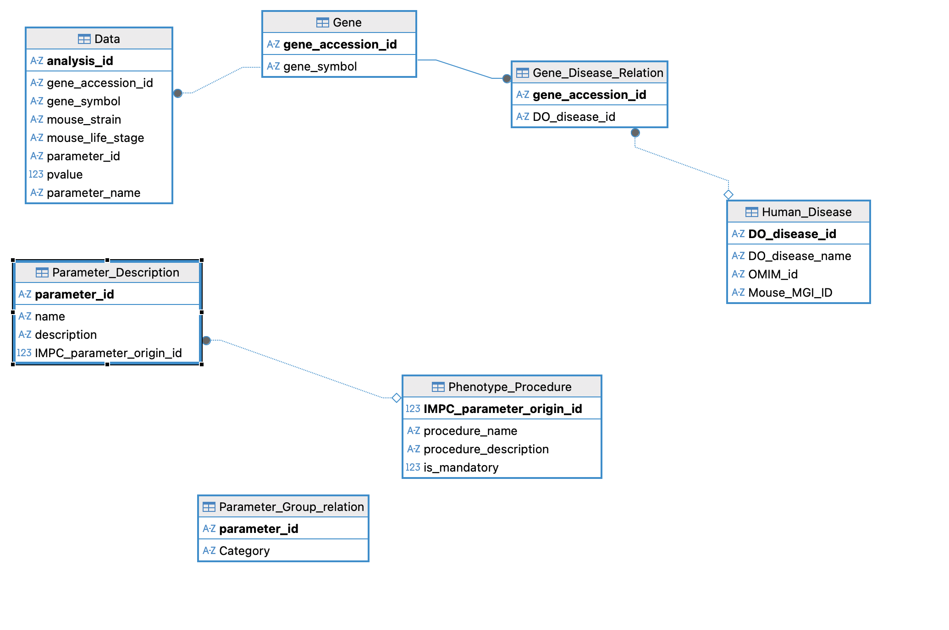
We still need to establish the following foreign-key relationships:
- Data.parameter_id linked to Parameter_Description.parameter_id
- Parameter_Description.parameter_id linked to Parameter_Group_relation.parameter_id

Summary Table of Foreign key relationships and directions

Relationship | Direction | Correct? | Notes
Gene_Disease_Relation → Gene | child → parent | ✔️ | Correct
Gene_Disease_Relation → Human_Disease | child → parent | ✔️ | Correct
Data → Gene | child → parent | ✔️ | Correct
Data → Parameter_Description | child → parent | ✔️ | Correct
Parameter_Group_relation → Parameter_Description | child → parent | ✔️ | Correct (your MySQL error is NOT due to direction)
Parameter_Description → Phenotype_Procedure | parent → parent | ⚠️ | Possibly backward depending on domain rules

